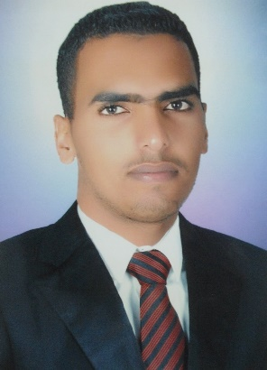
Amr Gamal Ateto

Tel: +20100 503 4025

+20120 396 2596
E-mail: amr.gamal1617@aun.edu.eg

PERSONAL INFORMATION:
Date of Birth: 26/1/1992
Gender: male
Marital Status: Single
Nationality: Egyptian

EDUCATION:
Assuit University, Assuit, Egypt
Bachelor of Mining and Metallurgy Engineering 2014
Grade: very good 83.47 %
Graduation Project: survey, Excellent 99%

EXPERIENCE:

Demonstrator at Mining Dep., Faculty of Engineering, Assiut Uni., (2016).

Inspector & draft surveyor at Baltic Control-Misr (Jan.2015-June2016).

Sampling observer at El Nasr Mining Com.
- Material handling at El Nasr Mining Com.
- Belt conveyor observer.
- Survey project at Assiut University.
- Project at Zog El-Bohar Mine, south of El-Qusseir, Red Sea

TRAINING

Misr Cement Co. (Qena)

Training on Extraction raw materials from the quarry, Sampling, Handling, Storage,

El Nasr Mining Co. (Red Sea)

Training on Maintenance of Mechanical Equipment, Phosphate (sampling, handling)

Certified in using and operating of TOPCON TOTAL STATION, 2013

Certified in using AUTOCAD program at the EEDC, Assiut Uni., 2013

SKILLS:
Language | -Fluent in Arabic and very good at English
Computer knowledge | Windows, MS Office, AutoCAD, Surfer, GIS, C++ programming

OTHER INFORMATION
Rewards:

- have been rewarded from the chief of Assiut University, 2013

REFERENCES:
Documents: Available upon request
http://www.aun.edu.eg/faculty_engineering/graduates/honor_board_13-14.htm

